Using Pre-cuts

1X- 8 ½” x 4 ½” 1X-8 ½” x 4 ½”
1X- 4 ½” x 4 ½” or 2X- 4 ½”x 4 ½”
2X- 2 ½” x 4 ½”
- Sew 2 ½” x 4 ½” (or 4 ½” x 4 ½”and go to step 3) pieces together
- Sew that “set” (2 ½” x 4 ½”) to the 4 ½” square.
- Sew that “set” to the 8 ½” rectangle
- Press
- Cut diagonally across the entire square starting at the 4 ½” square
- Sew 2 different halves together
- Trim to 8”
- Sew 4 squares together (yield=15 ½” sq)

48-8 ½” x 4 ½”
48-4 ½” x 4 ½”
96-2 ½” x 4 ½”
OR
48-8 ½” x 4 ½”
96-4 ½” 4 ½”

OR

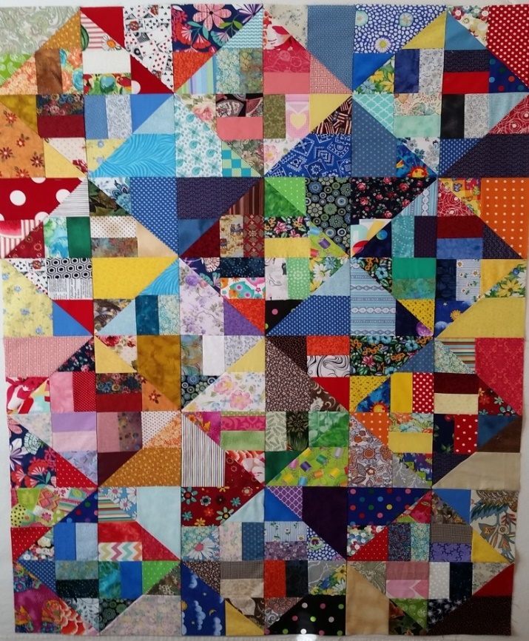
45” x 60”

